
Is Ishmael the ancestor of Mohammed and Islam?
In Genesis 17:10-15 God tells Hagar that he will greatly multiply her descendants. She was to have a son and name him Ishmael who will be “a wild donkey of a man” and live to the east of his brothers.
Note it is Ishmael, not Mohammed, that will be the “wild donkey of a man” and it is his hand will be against everyone, and everyone’s hand will be against him (Ishmael).
In Genesis 17:20 God then provides more detail for Ishmael. God says that he will bless Ishmael and multiply him by making him the father of twelve princes and a great nation.
Is this nation Islam?
In Genesis 25;12-18 we see that this promise was already fulfilled. God gave Ishmael 12 sons who are named and these formed the twelve tribes who settled in Havilah and Shur which is east of Egypt. This does not seem to be talking about a distant people group (i.e. Muslims) that would come 2400 years later.
We also know the tribes of Israel (fellow countrymen-Deut. 17:15 and Deut. 18:18) did not include the tribes of Ishmael.
According to Bukhari 3364, Abraham takes Hagar and Ishmael to Mecca when Ishmael was an infant and left them there. Abraham prayed and Allah brought water to the area so people could live there. Ishmeal grew and learned Arabic and married a women from his own tribe. Abraham returned and Ishmael was told to divorce his wife who he was living in poverty and send her home and he was to marry Jurhum. Allah prospered Ishmael and Jurhum. Abraham and Ishmael then established the Kaaba (Surah 2:127). In the Old Testament, Abraham goes to Egypt once before Ishmael is born (see figure 1 below) and we have no evidence that Abraham traveled over 700 miles southeast into an uninhabited area and built the Kaaba and little evidence that Mecca even existed in the time of Abraham. (see figure 2 below). Hadith 3364 notes when Abraham first arrived with his infant Ishmael; “During those days there was nobody in Mecca, nor was there any water”
In contrast the Bible says Abraham was 86 when he had Ishmael with Hagar and 99 when he had Isaac and both were circumcised (Gen. 17:24-25). After Isaac was weaned Abraham sent Ishamel and Hagar away to Beersheba/Southern Israel (Gen. 21:14). Ishamel was roughly 17 years old.
In Romans 9:8 Paul says:
“That is, it is not the children of the flesh who are children of God, but the children of the promise are regarded as descendants.”
It was Isaac who the descendants will be named (Gen. 21:12/Romans 9:7-9). Isaac descendants are the Israelites who are the children of the promise while everyone else is the ”children of the flesh.”
The evidence strongly supports Ismahel is not a distant relative of Muslims and Abraham never went to Mecca. Even if this were true, the Muslims are “children of the flesh” or gentiles (non-Israelites) and are in need of a savior. Paul reminds us that God:
“made from one man every nation of mankind to live on all the face of the earth, having determined their appointed times and the boundaries of their habitation, that they would seek God, if perhaps they might grope for Him and find Him, though He is not far from each one of us;… So having overlooked the times of ignorance, God is now proclaiming to mankind that all people everywhere are to repent, because He has set a day on which He will judge the world in righteousness through a Man whom He has appointed, having furnished proof to all people by raising Him from the dead …” (Acts 17:26-31).
The Bible never speaks of Mohammed and a future nation of Islam so the Muslims are simply included in the Great Commission where they are called to repentance and are in need of a savior. Christians are to make disciples of all nations (Matthew 28:18-20) which includes Muslims.
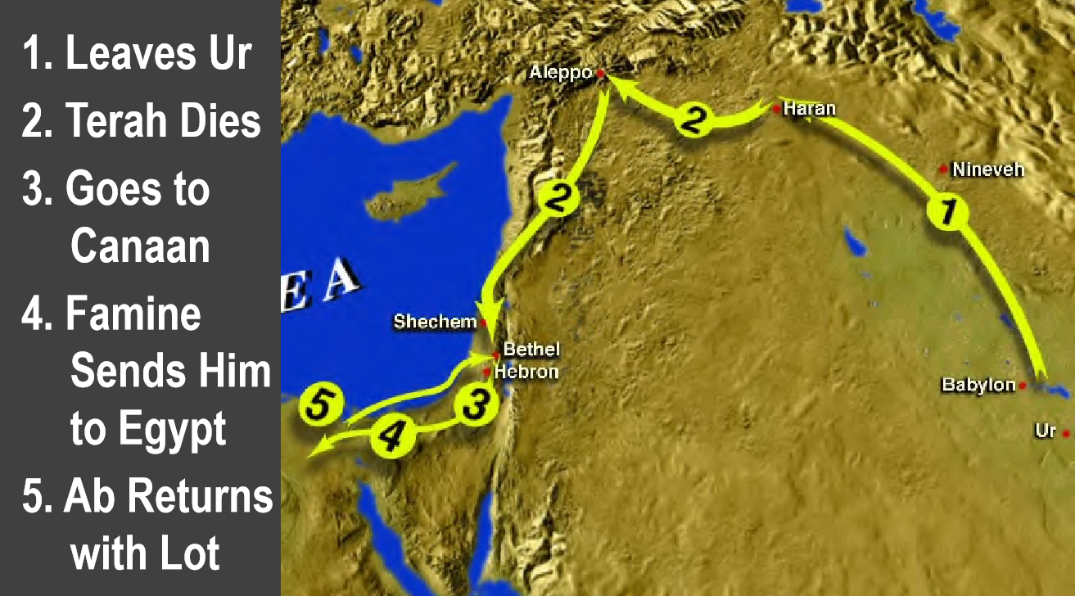
Figure 1 – Abraham’s Journey
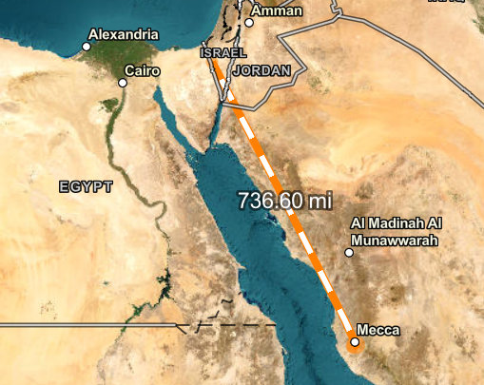
Figure 2 – Modern day location of Mecca/Kaaba 700+ miles away from Abraham’s route.

